**Notes By R V K ROHINI PRIYA**

**KUBERNETES:**

Kubernetes is used for deploying, maintaining and scaling applications. It is one of the highly advanced technologies.

1. Kubernetes is used as a host to applications in the form of containers
2. By using Kubernetes we can deploy and run many instances at a time
3. With this easy communication between different servers is possible.
4. It provides uniform interface for applications(means provides resources that are required for a particular application)
5. Kubernetes contains set of nodes on cloud.
6. We can scale the deployment (auto scaling is possible here).

There are two types of scaling.

* 1. **Horizontal Scaling**

In this we can comeback to the settings and increase the size of storage. But in this downtime occurs for some time..

* 1. **Vertical Scaling**

It automatically adds new instqances if load on application increases and vice-versa.

1. Without Container Engine we cannot run Kubernetes

Now a days we want our application to be continuously available to the end users without any downtime and interruptions. If not we loose our customers which is loss for us and our investors who invested on this.

Also me as a developer should not face any issue to deploy any new version to my application.

So Containerization with Kubernates helps to achieve this. Kubernates makes containerized applications to run when and where we want.

It also finds it resources and tools that are required for work.

With all these, simply we can say that Kubenetes is a production-ready and open source platform.

______________________________________________________________________

**STEPS TO ACHIEVE THIS:**

Create a Kubernetes Cluster –> Deploy an application –> Explore your application –>

Expose your application publicly –> Scale application –> Update application(if needed)

______________________________________________________________________

**ARCHITECTURE:**

Kubernetes works on two nodes

a. Master

b. Slaves(working servers or node) - each node can have multiple application pots with containers

- actual work is done by node

- Kubernetes is cluster and can have multiple nodes

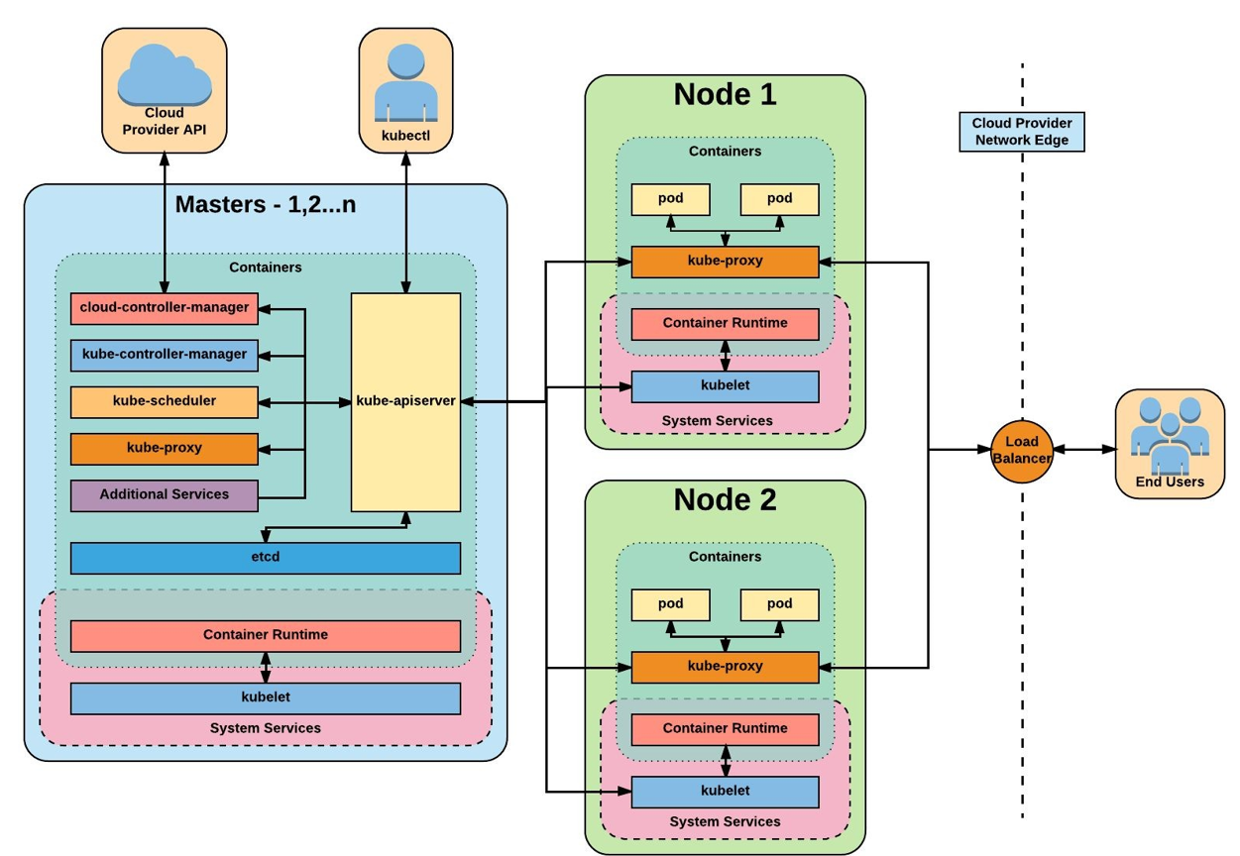

______________________________________________________________________

**SLAVE:**

Some processes must be installed on each node to schedule and manage the pots

Pot is a part of node that is used to run the Image of Container.

Parts of System Services

**1. Container Runtime:** (we are using docker)

- This is required to run a container of nodes

**2. Kubelet:**

- It interacts with both the container and node(pots) and schedules the process

- It assigns resources from the node to container and responsible to start and run the container

**3. Kube-proxy:**

- It is responsible for forwarding requests from services to pots

- It also has some logic that ensures good communication

______________________________________________________________________

**MASTER:**

Managing process is done by master node

Some processes must be installed on each node

**1. API server:**

- When user want to deploy a new application, they use API server(all user and also nodes must user API server to interact with Kubernetes)

- It acts as gateway for initial request, validate request and authentication and then do other processes which we need

- It provides us a medium between client and a cluster

**2. Kube-Scheduler:**

- It actually have all the details of node

- When our request is validated, scheduler runs our application on one of the nodes(assigns randomly)

- It decides based on the resources we needed(it just decides on which node the pod should run)

- It runs on the least busy node

- Then kubelet at the node runs and starts it.

**3. Kube-Controller-Manager:**

- Used for rescheduling when any one of the slave node is not working(as soon as possible)

- It simply and immediately detects if any pod is crashed

- It makes other working nodes to restart again the crashed ones

**4. etcd:**

- It simply has a cluster data which needs to be done

- It is a key-value store

- It also and must need backup(since it has data of what to do and whats happening)

- Every data(every changes made) in cluster is stored here, like if pod crashed etc.

**5.Kube-proxy:**

- Since all these applications works internally on kubernetes, we use proxy to run on outside environment.

Finally we can say that master works as a Controller.

______________________________________________________________________

**APPLICATIONS:**

In todays world Kubernetes is achieving a great importance and is being used almost at every places.

1. Parking System (In Dubai,UAE they are used, because of larger number of cars which can create a traffic problems)
2. Nuclear Power Plants (in Israel)
3. Fighter Aircrafts (in USA)

and many more.